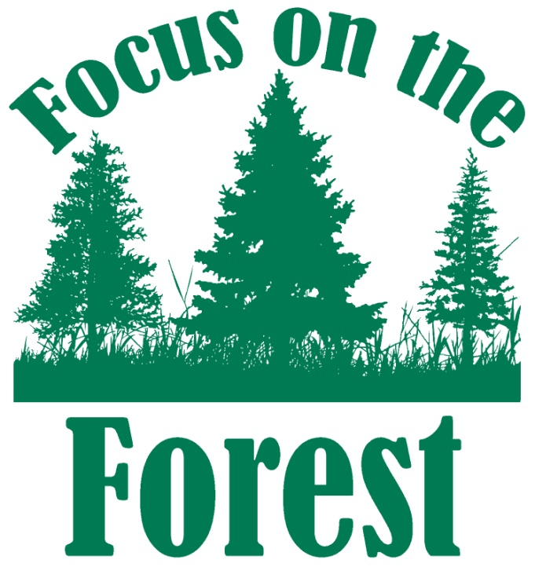
Cleaning up OUR National Forests
P.O. Box 248, Woodland Park, CO 80866
focusontheforest@gmail.com
www.focusontheforest.org

INFORMED CONSENT AND RELEASE OF LIABILITY WAIVER

Pre-Registration (if applicable) for: ______________________________ on __________________
(Name of Event) (Date)

All volunteers that participate with Focus on the Forest (FoF) on a periodic volunteer event on a unit of public or private lands must be signed up on the Volunteer Service Agreement and Waiver (VSA&W) form. By signing the form you agree to the terms of the event as defined in the Volunteer Service Agreement and affirmed by the organization and federal agency represents. Volunteers under age 18 must be signed by the parent or guardian. Please indicate on the form your willingness (yes) or unwillingness (no) to have your photographic, video or audio images in performance of volunteer duties used by Focused on the Forest and the US Forest Service. Your signature is valid for this event and any subsequent events for 1 year from the date signed, unless FoF is notified of changes in writing. . Information obtained on this form will be entered in on the VSA&W form, requiring only a signature in person when checking in at any event.

I (first, last name) _______________________________________________, understand that I am volunteering to help Focus on the Forest accomplish its mission as stated herein. I do this on a volunteer basis without anticipation of remuneration, in consideration of this opportunity to participate, which as value to me. I indemnify and hold harmless Focus on the Forest, a Colorado unincorporated non-profit association, Teller county, the State of Colorado and the US Forest Service, and their directors and officers, employees, agents, leaders, instructors, contractors or volunteers from and against all claims, demands, loss or injury to my person or property incurred thru negligence, or other acts or omissions, however caused by a director, officer, employee, agent, leader, instructor, contractor or volunteer of Focus on the Forest, Teller County, the State of Colorado and the US Forest Service as a result of or during my participation in volunteer service.

Pets are to be leashed during all events and owners are required to be in full control of their animal(s) at all time. Pet owners take full responsibility and liability for their animal(s) and the action of their animal(s).

I acknowledge that I have carefully read and fully understand this agreement and its contents. I am aware that this is a release of liability and a contract between myself and Focus on the Forest, Teller County, the State of Colorado, the US Forest Service and their directors, officers, employees, agents, leaders, instructors, contractors, and volunteers, and I sign it of my own free will.

Under the age of 18: Yes or No Photo Release : Yes or No

_____________________________________________ _________________________________________
Signature (or Parent/Guardian of a minor) Date PRINTED NAME

_____________________________________________ __________________________________________
Phone Number E-Mail address

